Post installation configuration for OpenELIS

# Post Installation

Note: The part for checking the installations are correct have been highlighted

## Reports

All reports should have the name of the lab and optionally the name of the director and a lab logo. If the lab name or the name of the director are left blank in the configuration then they will be blank on the report.

### 

### LNSP and Clinical

Turning the logo on and off

The logo for LNSP will be  and for all other labs it will be 

1. 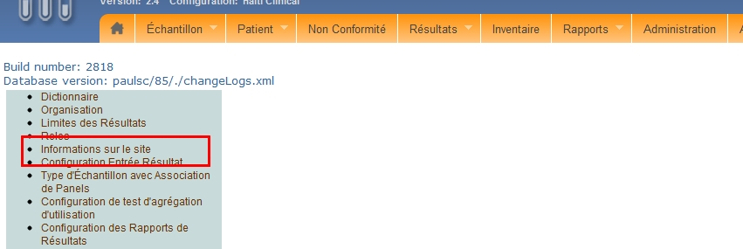
2. 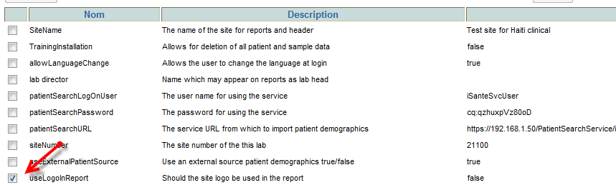
3. 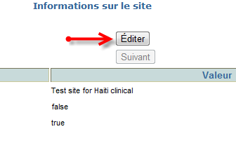
4. 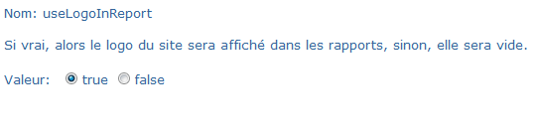

#### Setting site name

1. Repeat step 1.
2. 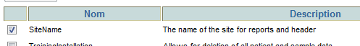
3. Select edit
4. 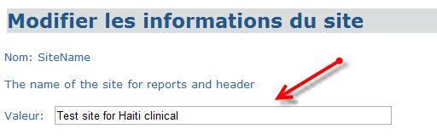

### Setting lab directors name

1. Repeat step 1
2. 
3. Select Edit
4. 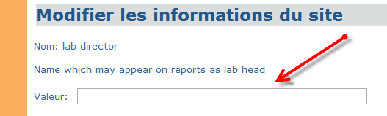

## Finding patients from iSante

Four values have to be set to be able to be able to automatically find iSante patients in OpenELIS. Note: within the next release or two the configuration for the service will move to it’s own page.

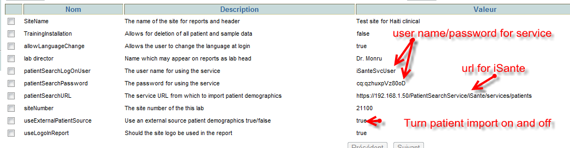

1. useExternalPatientSource. This has to be set to true to turn the feature on.
2. patientSearchLogonUser – this will be determined by iSante but the default is iSanteSvcUser
3. patientSearchPassword– this will be determined by iSante but the default is cq:qzhuxpVz80oD
4. patientSearchURL – the URL to use the service it is in the form of
   1. https://<hostname or IP>/PatientSearchService/iSante/services/patients
   2. where <hostname or IP> is the IP number of the machine on which iSante is running. Note that it does not include the port number.

To test if the names and passwords are correct paste the following in the address bar of a browser, replacing the IP address and password. The response will indicate that it was successful

https://<hostname or IP>/PatientSearchService/iSante/services/patients?first=Test&last=Test&name=iSanteSvcUser&pwd=<pwd>

## Sending results to iSante

Results are sent to iSante only for iSante patients. If useExternalPatientSource (from above) is set to false then there will not be any iSante patients in OpenELIS and so no results will be sent. The configuration for sending the results is done from the following page

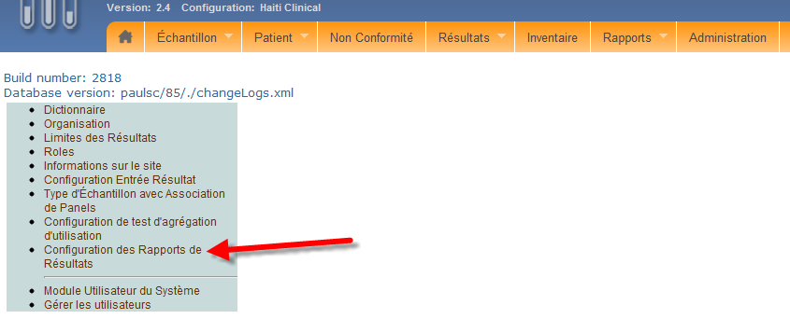

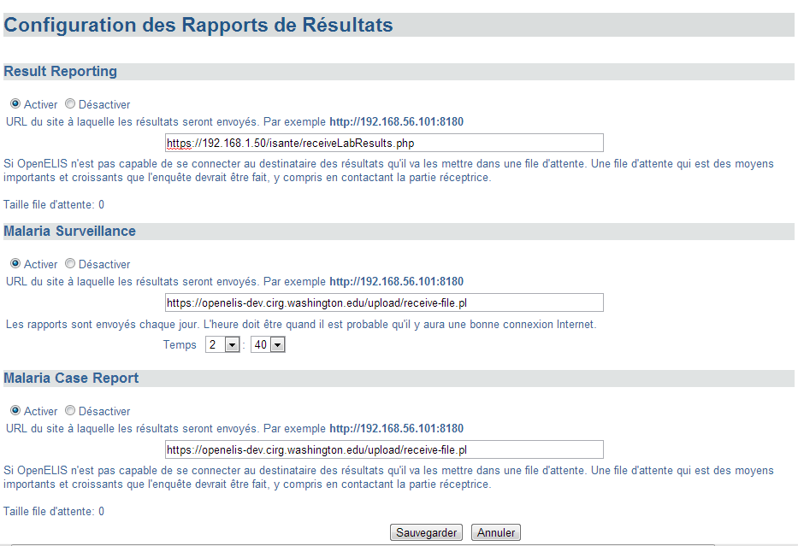 To send results:

Select the active button

Enter the correct URL. Note that the example given is not correct, it should be https://<IP address>/isante/receiveLabResults.php. Replace <IP address> with the IP address of iSante

To test paste https://<IP address>/isante/receiveLabResults.php into the address bar of a browser, replacing <IP address> with the IP address of iSante, and it will reply with "Connection successful.  This is the lab result receipt service for iSanté."

Sending Malaria results: At this time there is no established receiver of Malaria results so both the surveillance and case reporting should be disabled.

## Sending test counts to LNSP

There are two steps to send the test counts to LNSP. One is the tests are counted on the local machine and two is sending them to LNSP. The first should be scheduled for a time of day when the clinical machine is always turned on and the second should be scheduled for a time when both the clinical and LNSP machines are turned on and internet connections are good.

1. 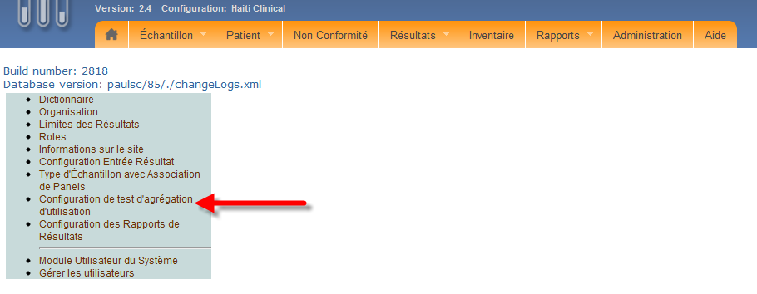
2. 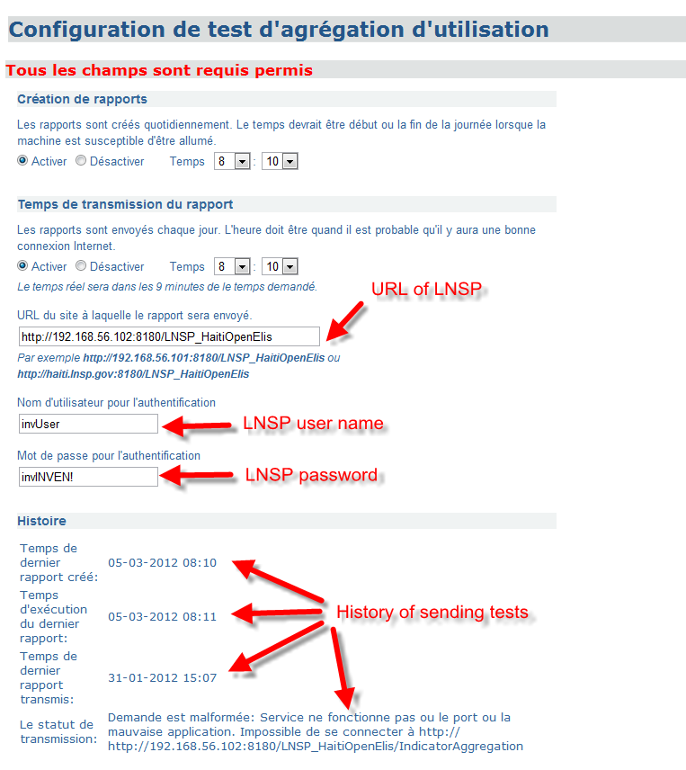
   1. The url of LNSP should include the port number, usually 8080 if it is run on Windows or 8180 if it is run on Linux
   2. The user/password are any valid user/password on LNSP.
   3. The history will give an indication of what happened the last time an attempt was made to send a report to LNSP. An update can be forced by changing the report creation or report send time and saving the page. If you do that (you may have to do it twice) you should be able to see if there were any problems connecting to LNSP. In the example given the LNSP machine was turned off.